A black box is memory device used to record data in car and aircrafts which helps in restoration of the events before the accidents.
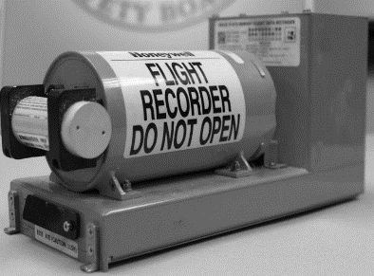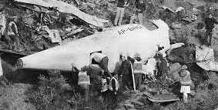
You are required to design a processor that will store data in the black box using Harvard architecture.
Question # 1
Clearly show the MMU (Memory Management Unit), Where will you attach the Black box. (diagram required).
Question # 2
In your opinion, how many pipeline stages are appropriate and why? ((diagram required))
Question # 3
You are required to introduce an assembly language instruction that will search a particular register value in the memory. What modifications are required on hardware (ALU) and software (virtual) sides.
Question # 4
What do think about the structural and Data Hazards. If they occur, then create a scenario?

